## Background

Calculus II

This is a continuation of Calculus I (MAT1512). It deals with the mathematics of change.

Outcomes:

- Calculate and use the derivatives of a function to sketch a graph of the function

- First derivative. Determine the relationship between the rates of change of various quantities in the rates-of-change word problem.

- Solve maximum or minimum word problems using the theory of derivatives.

- Ability to use L’Hopital’s rule to determine limits of indeterminate forms.

- Calculation of the volumes of solids of revolution.

- An improper integral is tested for convergence or divergence and evaluated if convergent.

- Integration techniques to evaluate integrals.

- Taylor polynomial of any order at a given point.

**Lesson 0**

Revision: Limits

Limits are the value a function approaches as the input “approaches” some value. They are used to define continuity, derivatives, and integrals.

We do not care about the output (of a function) at a certain point, but more what happens around the point.

Limits help solve the problem of indeterminate form

Calculating instantaneous velocity is an example of a limit

Example: The function and the limit differ

*LHS: The limit as x approaches 2 is 2*

*RHS: The limit as x approaches 2 is 2*

*The limit as x approaches 2 is 2*

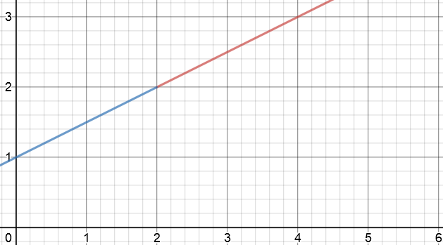

Example: The LHS and RHS limit differ

*LHS: The limit as x approaches 2 is 2*

*RHS: The limit as x approaches 2 is 2*

*The limit as x approaches 2 does not exist*

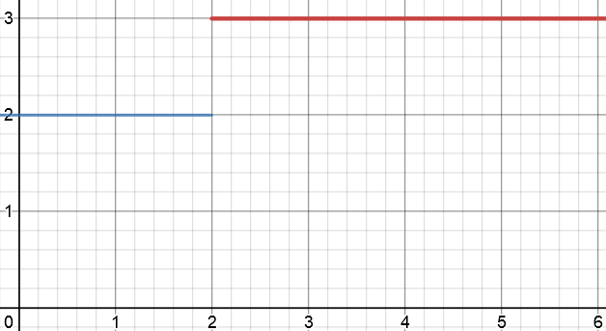

Example: The limits at inifinity

*LHS: The limit as x approaches -infinity is -1*

*RHS: The limit as x approaches infinity is -1*

*Reciprocal graph. Asymptotes @ x=2, y=-1*

<https://www.youtube.com/watch?v=nJZm-zp639s>

**Common** **(PFGE)** Use these methods in order. If one fails, try the next

[1] Plug in values

*Always start by plugging in the x value*

[2] Algebra. Factorization

*Indeterminate form . Factorize and the plug-in x value*

If you use [2] and you get an answer over zero, then DNE (does not exist)

Other DNE examples

[3] Algebra. Get common Denominator

*Reciprocal Substitute*

[4] Expand Parentheses

*Expand then simplify*

**Uncommon (STA)**

[5] Square root in numerator (in rational expression)

*Multiply by conjugate (differentiation). Remember to change sign of 2nd term*

[6] Trig functions (indeterminate form)

*Special property: or*

*Special property: or*

*because*

[7] Absolute Value

*Piecewise definition of ABS function:*

*Find see if LHS limit = RHS limit*

<https://www.youtube.com/watch?v=nViVR1rImUE>

**Limits at infinity**

*Special property:*

[8] Polynomial/Constant

*Lower degree terms (2x and 5) irrelavant matter here*

[9] Rational

*degree_N < degree_D*

*ratio of leading coefficients*

*degree_N = degree_D*

*degree_N > degree_D*

[10] Trig functions

*Special property: or*

*Special property: or*

*also 0*

[11] Exponential

*eval:*

*eval:*

*Sub*

*Sub*

[11] L’Hopital’s Rule

*Special property:*

Example: natural logs

**Continuity**

A function is continuous at a if

*the limit of the function at input a is defined*

**Lesson 0**

Revision: Derivatives

Derivatives are the slope of a function. It calculates the instantaneous rate of change at each point of the old function.

Common derivatives:

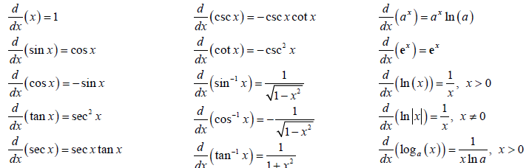

What is and what is the difference between and ?

is a function that takes one input.

Differentiation incomplete

*differentiation-with-respect-to-x*

or for brevity ,is a function with its input y.

Differentiation complete

*the result of taking the derivative-with-respect-to-x of y*

[1] Power Rule

[2] Product Rule

[3] Quotient Rule

[4] Chain Rule.

Use this when you have a composition function (in the form )

First differentiate Then differentiate

Multiply by

Chain Rule – Exponential

*Common derivative*

Chain Rule – Log

*Common derivative*

Chain Rule – Root

Chain Rule – Chain Rule with the Product Rule

*Product rule -> Chain Rule*

*Chain rule -> Product Rule*

)

[5] Implicit Differentiation

*find the derivative of y with respect to x*

*without having to solve the given equation for y.*

*product rule*

*isolate*

**Lesson 1**

Sign Patterns

Critical point

* When the first derivative is zero or does not exist, we have a critical point

Local Maximum

* When the first derivative changes from a positive to a negative, we have a local maximum
* Has a critical point

Local Minimum

* When the first derivative changes from a positive to a negative, we have a local maximum
* Has a critical point

Concavity

* Inflection points occur where concavity changes

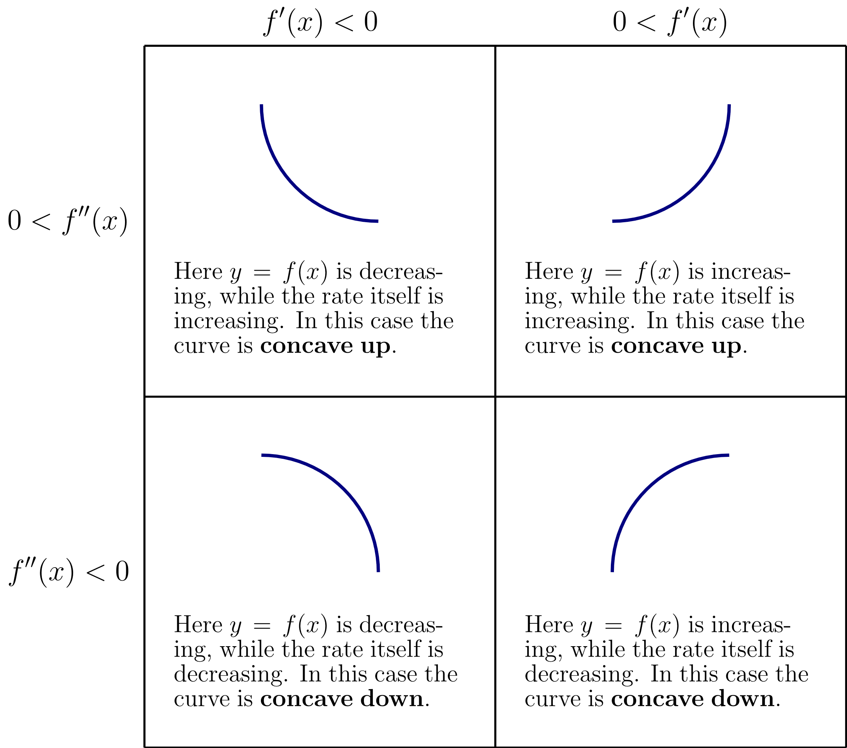

**Lesson 2**

Integration

This is the antiderivative of a function. It is used for calculating things like areas, volumes, and central points.

integral

derivative of integral

function

what does all this mean?

integral of the function

infinitesimal displacement along x

limits of integration

[1] Power Rule

[2] Trig

[3] U Substitution

Choose an expression for

Choose an expression for .

*Choose the one that is easiest to differentiate from* . Usually the one in brackets

Integrate and

Substitute original back

Sometimes you might need to manipulate

Sometimes you might need to manipulate

Sometimes you need to re-write the question with brackets

-

-

-

-

-

-

[3] Integration by parts

First try your other methods, in succession

[1] Power Rule [2] Trig [3] U-Substitution

If none of these work, Use integration by parts

Take your original integral, re-write into a form you can use

Choose an expression for

*Choose the one that is easiest to differentiate*

Choose an expression for . (L-I-A-T-E)

Differentiate for

Integrate for

To choose an expression for and more accurately, use LIATE

The first letter that comes up, use for

The second letter that comes up, use for

Logs

Inv trig

Algebraic

Trig

Exponent

In this example:

Algebraic

Exponent

TE are interchangeable

In this example:

Exponent

Trig

Integrate by parts again

We already solved . Therefore:

[3] Trig Substitution

If no other method is working, and you have a radical (), use trig substitution

Sub

*TOA*

Sub

*SOH*

Identify the form you have

*is a constant*

*is*

Compute a set of values

*Substitute*

*Differentiate for*

*solve for (inverse trig)*

Complete a reference

Triangle

*SOH CAH TOA*

Sub triangle values

Sub

*CAH*

**Inverse trig functions**

**Half angle formulas**

**Double angle formulas**

Remember that is assumed positive, so can be written

Apply sum rule

U-Substitution

Sub ref triangle values

**Lesson 3**

Optimization

In order to optimize in calculus, we need to be able to use some derivative equal to zero.

ASS 1 Q2: You are designing a poster to contain 50 of printing with margins of 4 each at the top and bottom and 2 at each side. What overall dimensions will minimize the amount of paper used?

2

Product Rule

Critical point

Study List

[x] Sign patterns

[ ] Optimization

[ ] Rolle’s Theorem

[ ] Mean Value Theorem

[ ] Area between curves, solids of revolution

[x] Integration

[x] Integration U Substitution

[x] Integration by parts

[x] Integration by trig substitution

[ ] Taylor polynomials

Revision List

[x] Trig identities/Formulas

[ ] Derivatives – Extrema

[ ] Derivatives – Integrals

[ ] Derivatives – Common Integrals